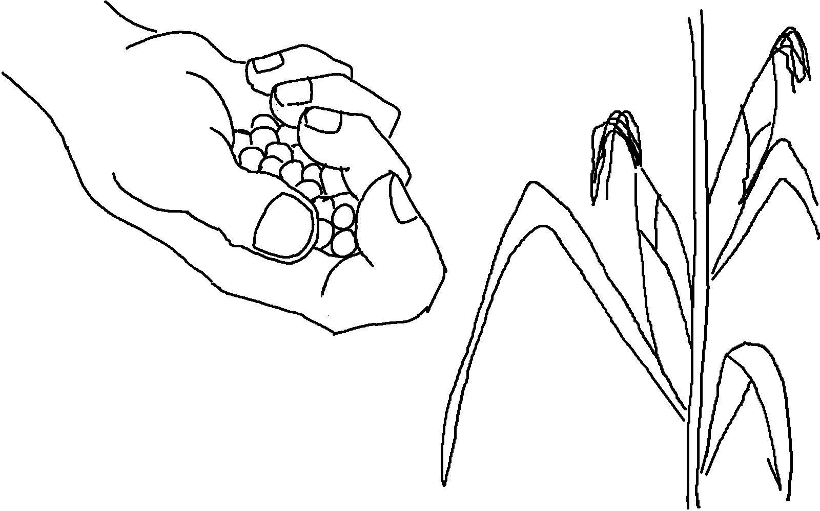

You will always _ _ _ _ _ _ _ what you _ _ _ _ _.
Galatians 6:7 _{NLT}

